Making an Impact:
Changing the Course

OBJECTIVE: You’re creating a maximum of a 4 page (8 for Honors). You'll research about a person, event, or era which/who had a lasting impact on the world.
RESEARCH QUESTION:

REQUIREMENTS:
Paper Set Up -
Use purdueowl.edu for formatting questions and samples.
Requirements for your paper:
Element | Check
Length (refer to CSA directions for On-level or Honors)
12 point, Times New Roman
Double Spaced
Heading
Header (be sure to change font and size)
Title (the assignment is NOT your title; honor your paper with a title worthy of the work you put into it)
1 print source (book)
2-4 database
1 primary source (required for Honors)
All sources are recent, reliable, and relevent
15 notecards with quotes, nine of which are included in your paper
A works cited page in MLA format

Use a critical lens to guide your research so you don’t report back irrelevant information. For example, no one really cares when George Washington was born unless it’s an unusual story and relevant to your research (In most cases, everyone was born normally, so who cares.) You’re better off using a critical lens like How George Washington revolutionized the military (keeping this in mind, GW’s birthdate and grammar school are obviously irrelevant).

Content Requirements -
1. The introduction will include:
  - A thought-provoking attention grabber that makes your reader want to read the rest of your paper.
  - A statement linking your attention grabber to the topic and establishing the topic’s relevance. Begin to elaborate using your critical lens.
  - A solid thesis following the formula:

Subject + Your Opinion (w/ reason) = A Thesis Statement

2. The body:
  - The sections:
    - Do not simply tell about the era, person, or event. Remember to focus on your critical lens – use it to funnel information; then how did the person/era/invention change the world? This should include information about the area of exploration and the need for this type of change. For example, we didn’t NEED the Holocaust, but we needed people to stop it.
    - Discuss the path: accomplishments and failures and findings. Examine the explorer’s impact on people.
  - Appropriate transitions between each section.
  - Supporting evidence for each main point derived from your research.
  - All supporting evidence must be paraphrased or cited using internal citations according to MLA guidelines.
3. The conclusion will include:
  - A revised thesis reminding the reader of your paper’s purpose.
  - Summarize your main points
  - A strong final thought to leave your reader thinking about your research. The moment of “wow!”

Name: ______________________________________________ Period: __________

Recent, Reliable, and Relevant Sources with Impact

Recent: What is the date of the book? Is my topic a current event that requires the book be published within the past 2-3 years to be accurate?
Relevance: What information do I plan to take from this book? Will the information help me prove the thesis of my research paper?
Reliable: Is this author or publisher recognized as a reliable and believable source?

Creating a Citation for a Book:
At the end of the writing process, you will need to create a works cited page listing all of the sources you used when writing your research paper. The works cited page will require you to list your source information in a format known as MLA (Modern Language Association) format. The MLA formatting for a book looks like this:
Author’s last name, First name. Title of the Book. Name of publisher, year of publication.

Practice Source Approval
Source # _____: Primary or Secondary Approved Not Approved
Type of Source (circle one): Book Encyclopedia Magazine Newspaper Website
Found in (circle one): Hard copy Database Online search engine
Citation Entry: ______________________________________________________________________
__________________________________________________________________________________________
__________________________________________________________________________________________
Is the source recent enough for facts and statistics? __________________________________________
Reliable (Who published this?) ____________________________________________________________
How do you know that this sponsor or publisher is reliable? __________________________________
_________________________________________________________________________________________
Relevance: What kind of information are you going to take from this source for the main point?
__________________________________________________________________________________________

Name: ______________________________________________ Period: __________

Recent, Reliable, and Relevant Sources with Impact

Recent: What is the date of the book? Is my topic a current event that requires the book be published within the past 2-3 years to be accurate?
Relevance: What information do I plan to take from this book? Will the information help me prove the thesis of my research paper?
Reliable: Is this author or publisher recognized as a reliable and believable source?

Creating a Citation for a Book:
At the end of the writing process, you will need to create a works cited page listing all of the sources you used when writing your research paper. The works cited page will require you to list your source information in a format known as MLA (Modern Language Association) format. The MLA formatting for a book looks like this:
Author’s last name, First name. Title of the Book. Name of publisher, year of publication.

Practice Source Approval
Source # _____: Primary or Secondary Approved Not Approved
Type of Source (circle one): Book Encyclopedia Magazine Newspaper Website
Found in (circle one): Hard copy Database Online search engine
Citation Entry: ______________________________________________________________________
__________________________________________________________________________________________
__________________________________________________________________________________________
Is the source recent enough for facts and statistics? __________________________________________
Reliable (Who published this?) ____________________________________________________________
How do you know that this sponsor or publisher is reliable? __________________________________
_________________________________________________________________________________________
Relevance: What kind of information are you going to take from this source for the main point?
__________________________________________________________________________________________
Name: ______________________________________________ Period: __________

Honors students: You must have at least one of these filled out on this sheet.

Practice Source Approval
Source #_____: Primary or Secondary Approved Not Approved
Type of Source: Database
Citation Entry: ______________________________________________________________________
__________________________________________________________________________________________
Is the source recent enough for facts and statistics? _________________________________________
Reliable (Who published this?) ____________________________________________________________
How do you know that this sponsor or publisher is reliable? __________________________________
_________________________________________________________________________________________
Relevance: What kind of information are you going to take from this source for the main point?
__________________________________________________________________________________________

Practice Source Approval
Source #_____: Primary or Secondary Approved Not Approved
Type of Source: Database
Citation Entry: ______________________________________________________________________
__________________________________________________________________________________________
Is the source recent enough for facts and statistics? _________________________________________
Reliable (Who published this?) ____________________________________________________________
How do you know that this sponsor or publisher is reliable? __________________________________
_________________________________________________________________________________________
Relevance: What kind of information are you going to take from this source for the main point?
__________________________________________________________________________________________

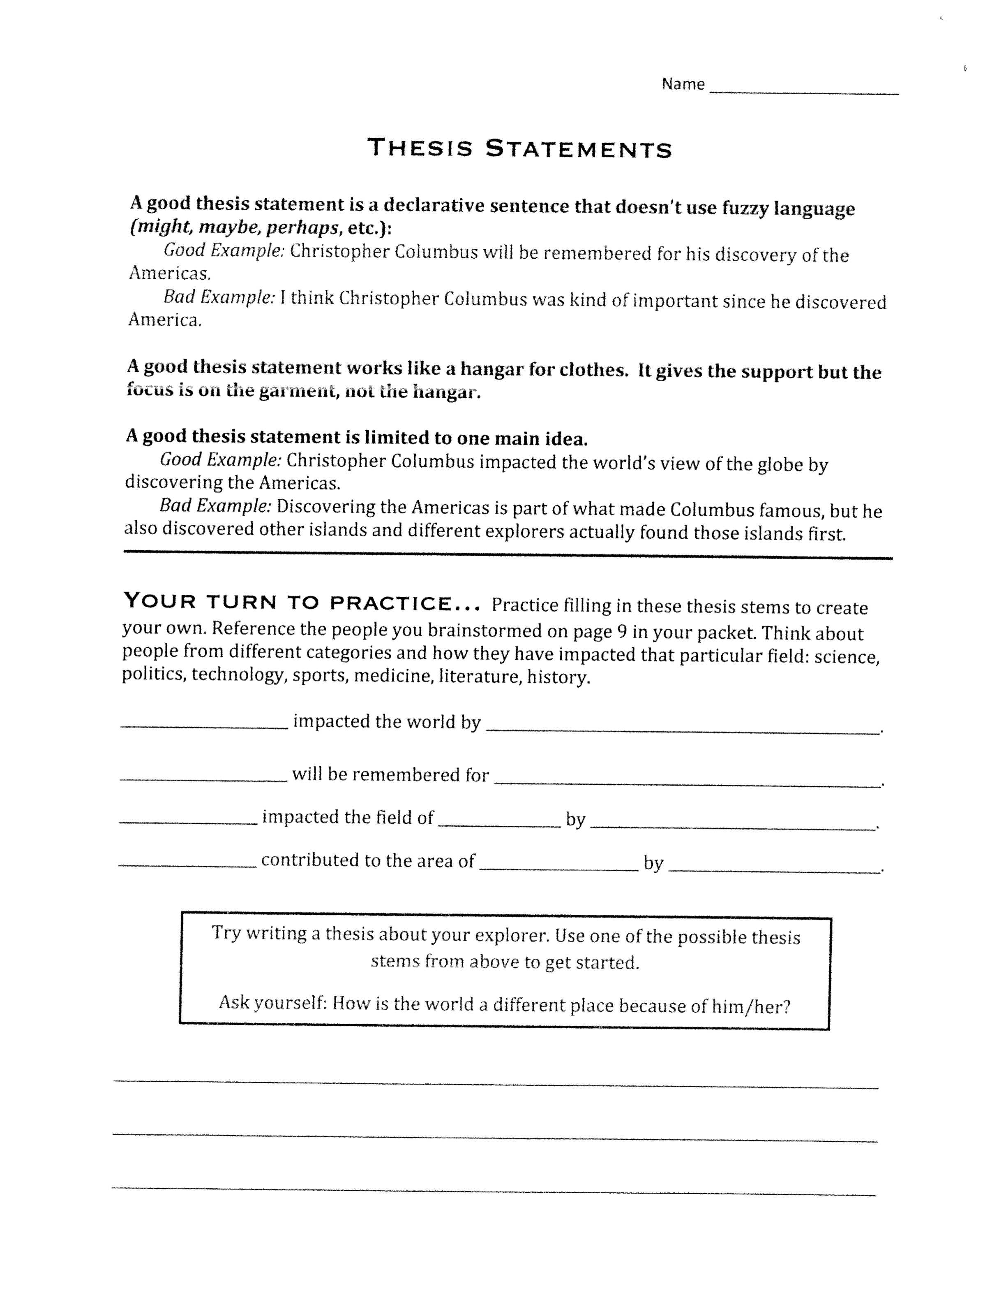
1.

2.
3.
4.
Preparing for Impact
(Taking Notes)

One of the biggest challenges when writing a research paper is trying to keep your facts and research organized. This note-taking format will help keep everything straight and will guarantee you know which source and page number you retrieved your information from. HINT: It can be a good idea to color-code your cards according to the focus of your paper: impact on society, relevance to quote, etc. With well-done note cards, you can simply write your paper from your cards!

You should write your page number here also
Heading: subject and/or context of note Source: Author
Write your ONE main note here: one idea, one main point, or one
paraphrased idea. Be sure to use quotation marks if it is a direct
quote.
Pg. 87 Make sure to write down the page number from the book or
article where you found your fact, because you will need to
include it within your citations.

Sample:
United Nations Step In Keller, p 90
A worldwide campaign of protest has already begun against the life
sentence imposed by South Africa’s Supreme Court on African Nationalist
leader Nelson R. Mandela and seven other foes of apartheid. As the debate
and votes in the United Nations this past year have shown, most of the
world regards the convicted men as heroes and freedom fighters. They are
considered the George Washingtons and Benjamin Franklins of South
Africa, not criminals deserving punishment.
How will this information support your critical lens?

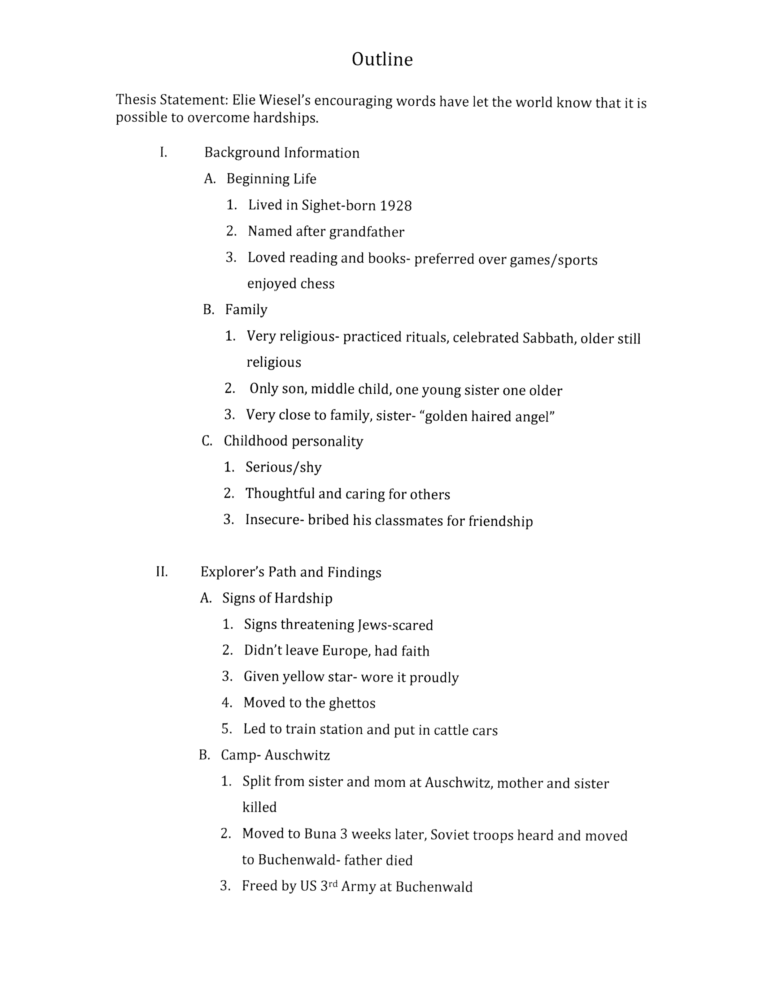
How Will This Information Fit Into My Research?
Once you have taken your notes over your topic, create an outline for your research. An outline would look something like this:

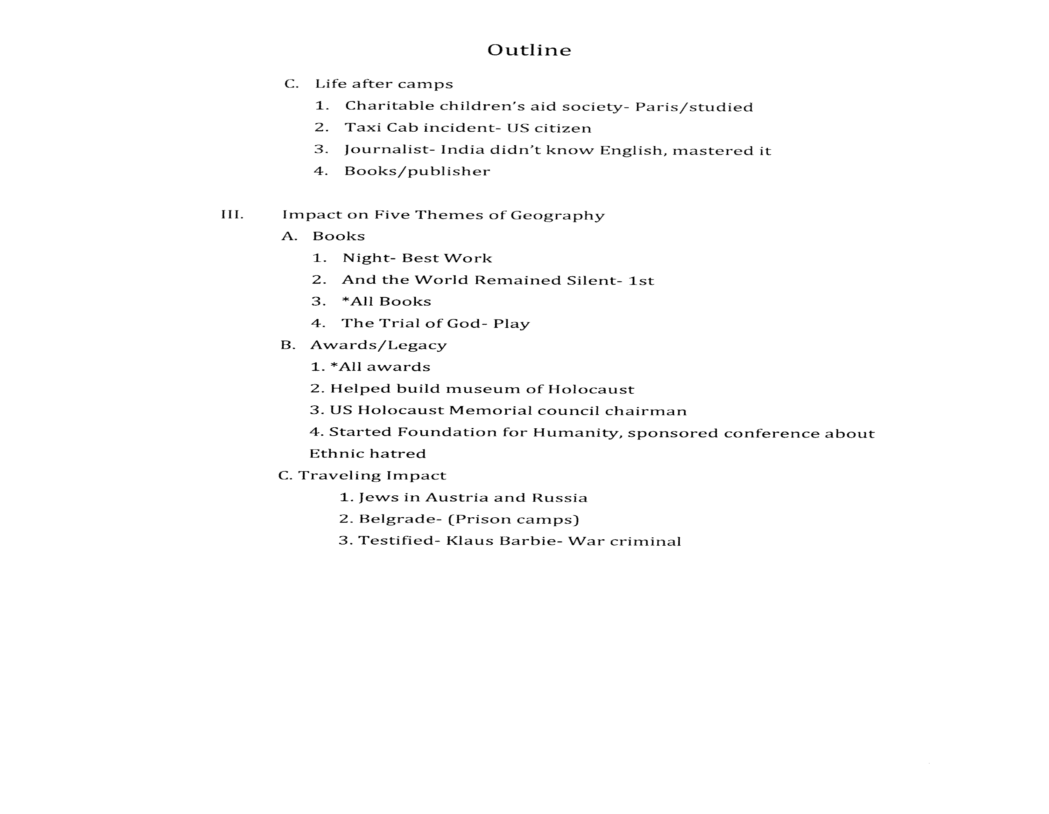

Name: ______________________________________________ Period: __________
Outline
The Map of Impact (for your topic)

Introductory statement (Hook): __________________________________________________________________________

______________________________________________________________________________________________________________

_______________________________________________________________________________________________________________

Elaborate on hook, give context and begin to funnel your topic through your quotation:
_______________________________________________________________________________________________________________

_______________________________________________________________________________________________________________

_______________________________________________________________________________________________________________

_______________________________________________________________________________________________________________

_______________________________________________________________________________________________________________

_______________________________________________________________________________________________________________

_______________________________________________________________________________________________________________

_______________________________________________________________________________________________________________

Thesis statement:___________________________________________________________________________________________

_______________________________________________________________________________________________________________

I. Main Point #1 ______________________________________________________________________________________

A.______________________________________________________________________________________

1.______________________________________________________________________________

2.______________________________________________________________________________

3.______________________________________________________________________________

B.______________________________________________________________________________________

1.______________________________________________________________________________

2.______________________________________________________________________________

3.______________________________________________________________________________

C.______________________________________________________________________________________

1.______________________________________________________________________________

2.______________________________________________________________________________

3.______________________________________________________________________________

II. Main Point #2 _______________________________________________________________________

A.______________________________________________________________________________________

1.______________________________________________________________________________

2.______________________________________________________________________________

3.______________________________________________________________________________

B.______________________________________________________________________________________

1.______________________________________________________________________________

2.______________________________________________________________________________

3.______________________________________________________________________________

C.______________________________________________________________________________________

1.______________________________________________________________________________

2.______________________________________________________________________________

3.______________________________________________________________________________

III. Main Point #3 ________________________________________________________________

A.______________________________________________________________________________

1.__________________________________________________________________

2. __________________________________________________________________

3. __________________________________________________________________

B. _____________________________________________________________________________

1.__________________________________________________________________

2. __________________________________________________________________

3.__________________________________________________________________

C.______________________________________________________________________________

1.__________________________________________________________________

2.__________________________________________________________________

3.__________________________________________________________________

You may (should?) have more main points… so use additional paper as needed.

Conclusion: Restate your thesis in different terms (restate your lens quote here, too):

________________________________________________________________________________________________________

________________________________________________________________________________________________________

Summarize the main points of your paper: __________________________________________

__________________________________________________________________

__________________________________________________________________

__________________________________________________________________

Leave your reader with an outstanding parting thought: _______________________________________

__________________________________________________________________

